AWS EC2 Instance Creation

Sanskar Yadav

3rd Sem BSc DS

A dedicated AWS cloud environment for learning, developing, testing, and deploying applications while gaining practical experience with Linux and cloud .

EC2 Launch Interface
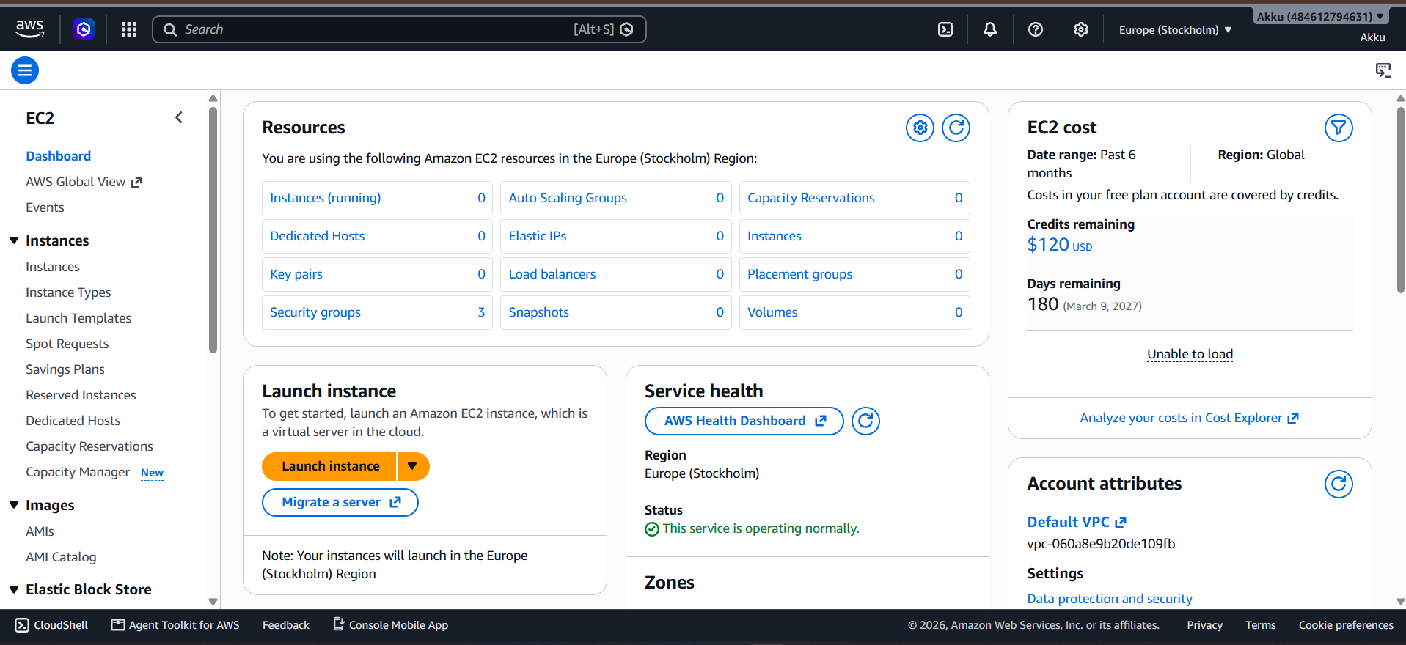

The Launch an Instance interface is used to configure and create a new virtual server on AWS.
It provides different options for selecting the AMI, instance type, key pair, network settings, storage, and security configuration.
Each option can be customized according to the requirements of the application or project.

Launch An Instance

Name and Tags

The Name field is used to assign a unique and meaningful name to the EC2 instance.
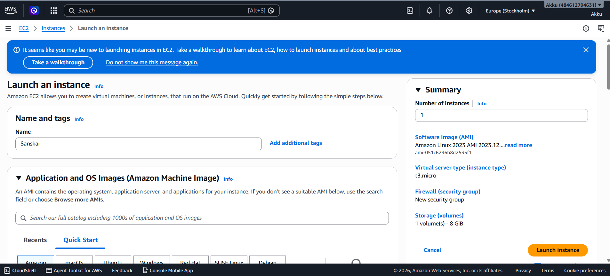

Application and OS Images

The Application and OS Images section is used to select the operating system and software environment for the EC2 instance.
AWS provides different Amazon Machine Images (AMIs) such as Amazon Linux, Ubuntu, Windows, and other pre-configured options.
The selected AMI determines the initial software and operating system installed on the virtual server.
For this instance, an appropriate Linux-based AMI is selected according to the project requirements.

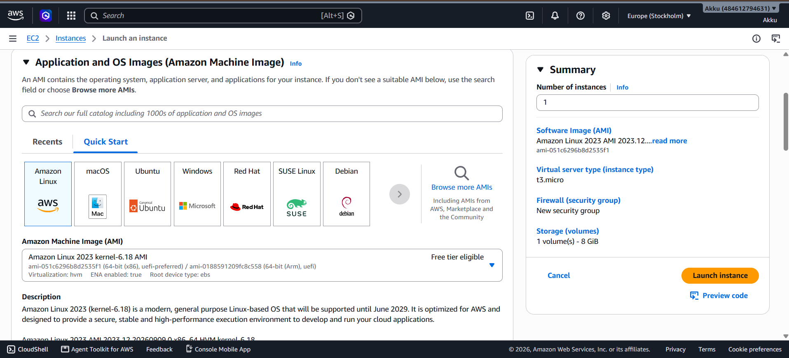

Instance Type

The Instance Type determines the computing resources available to the EC2 instance, such as CPU, memory, and network performance.
For a Free Tier eligible setup, t2.micro or t3.micro may be available depending on your AWS account and region.
These small instance types are suitable for learning, testing, and basic applications.
The available free-tier option should always be checked in the AWS console before launching the instance.

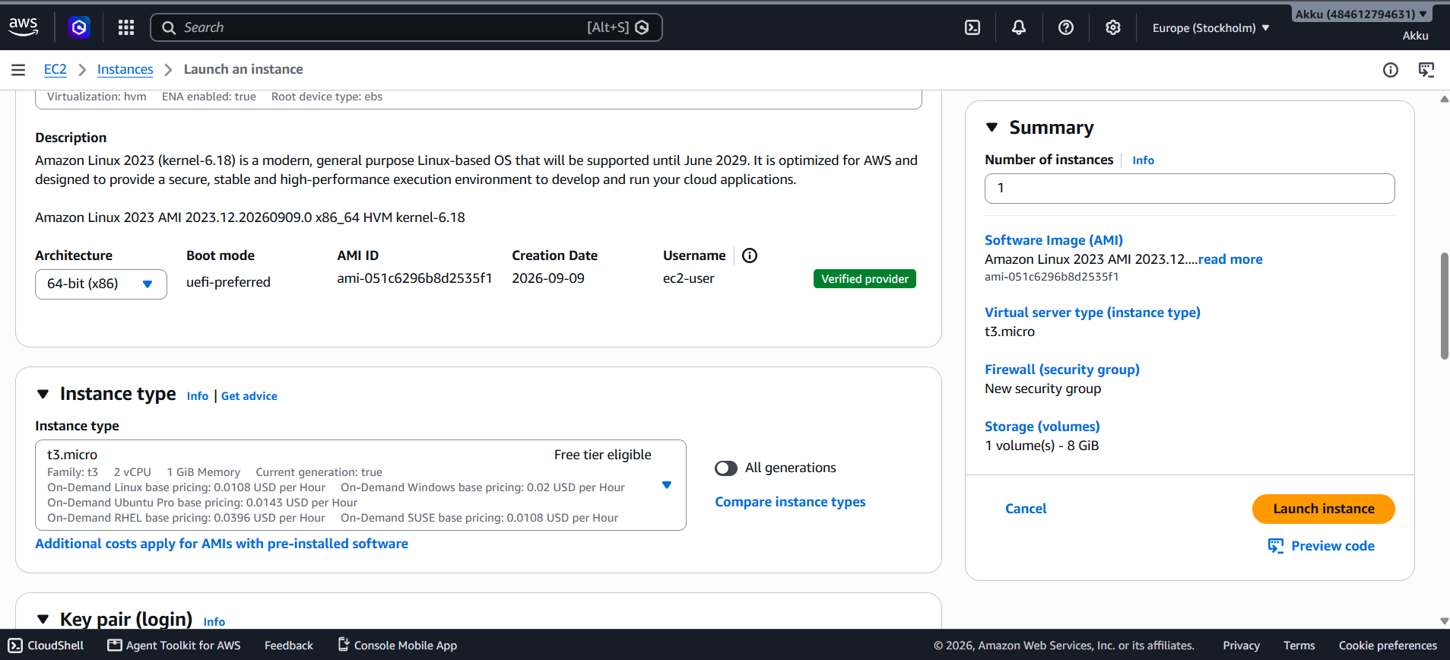

Key Pair

A Key Pair is used to securely connect to an AWS EC2 instance.
It consists of a public key stored by AWS and a private key (.pem file) that is kept by the user.
The private key is required to authenticate and access a Linux EC2 instance through SSH.
For security, the private key should be stored safely and never shared with anyone.

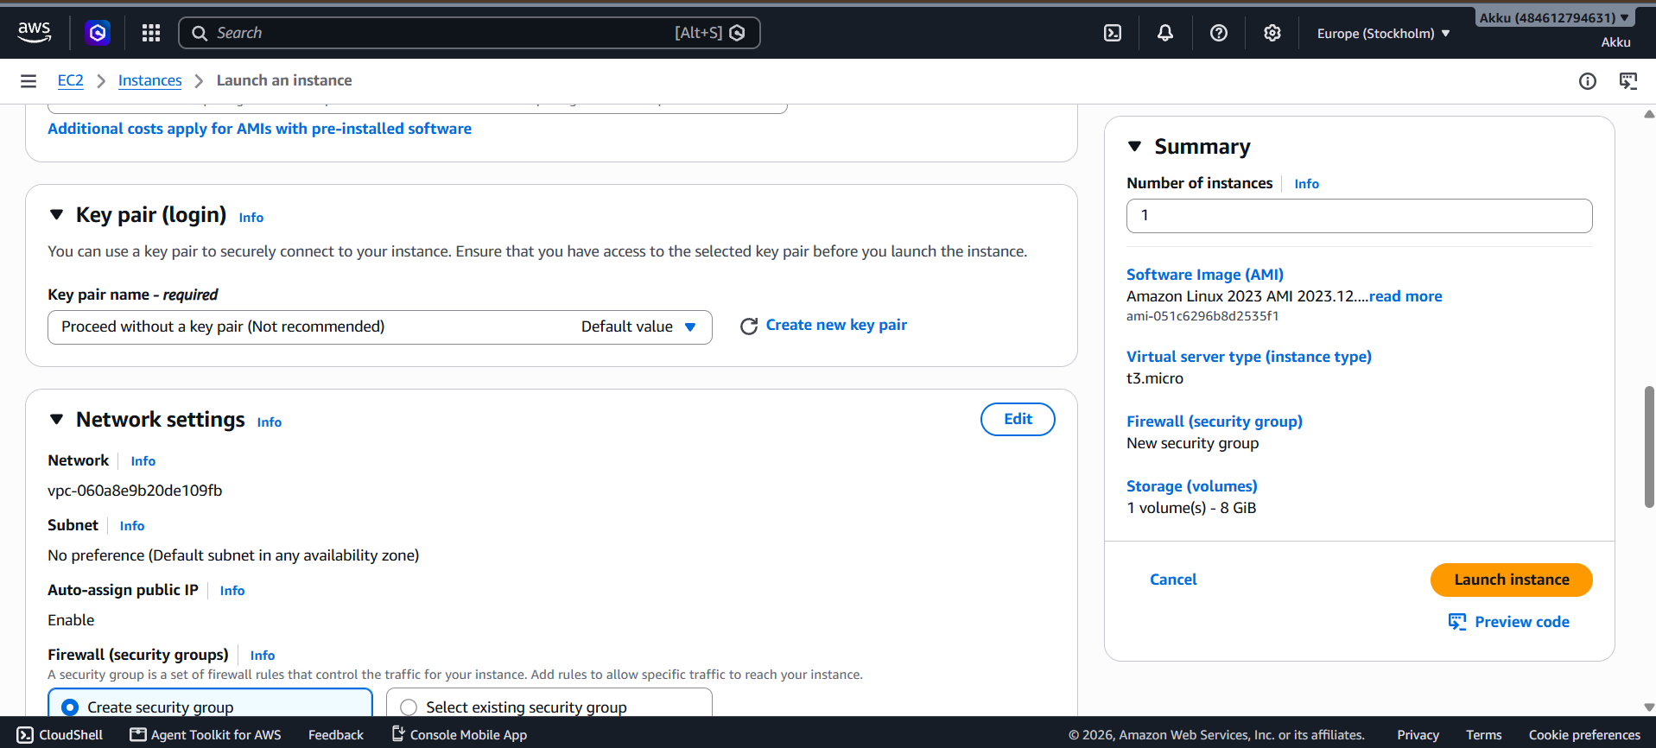

Network Setting

The Network Settings section is used to configure the network connectivity and security of the EC2 instance. It includes options such as VPC, Subnet, Public IP, and Security Group.
The security group can allow specific traffic such as SSH (Port 22), HTTP (Port 80), and HTTPS (Port 443) according to the requirements.
SSH is used for remote server access, while HTTP and HTTPS are used to access web applications running on the instance.

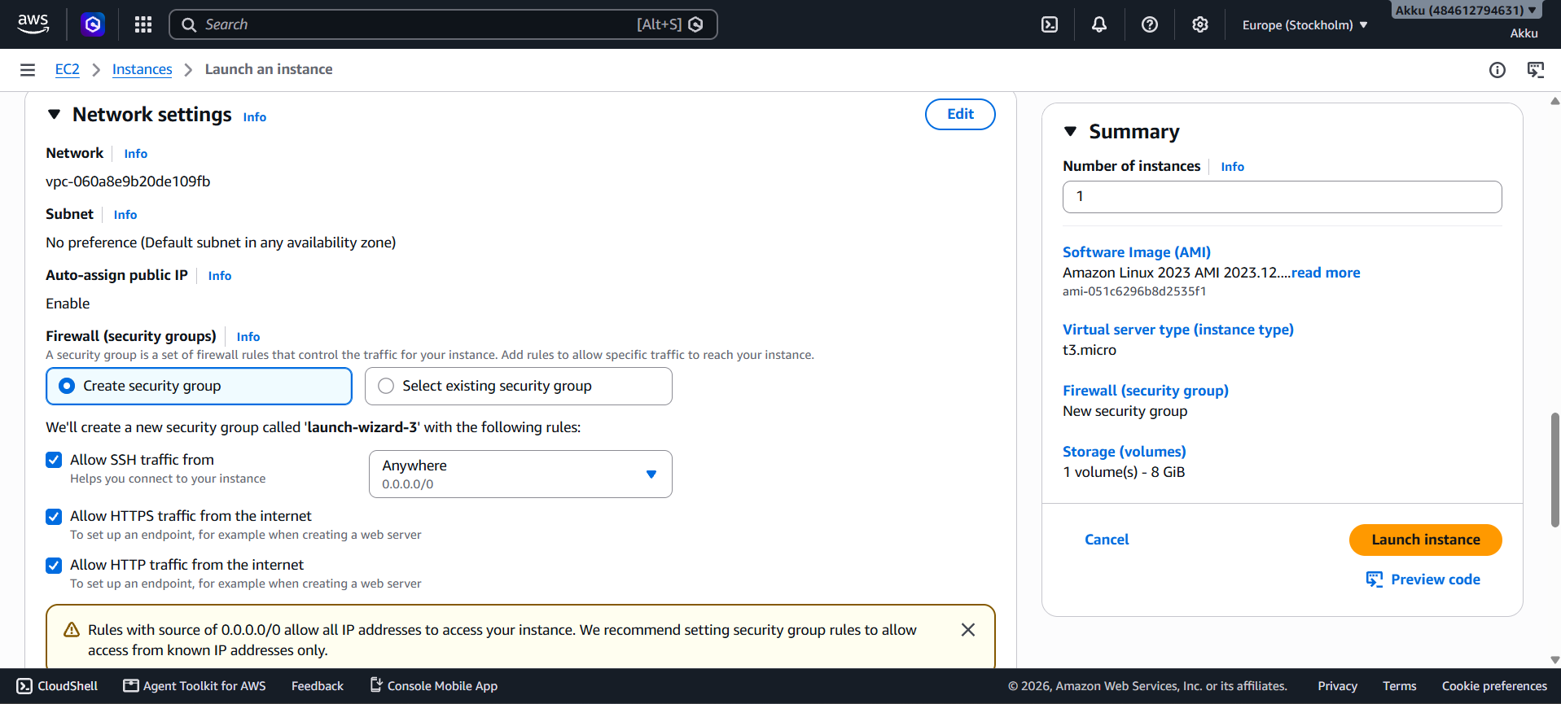

Summary of Instance

The Summary section provides an overview of the main configurations selected for the EC2 instance.
It shows the number of instances, selected AMI, and instance type before launching.
It also displays the configured security group and storage volume details.
This section helps verify that the important settings are correct before deployment.
After reviewing the configuration, “Launch instance” can be selected to create the EC2 instance.

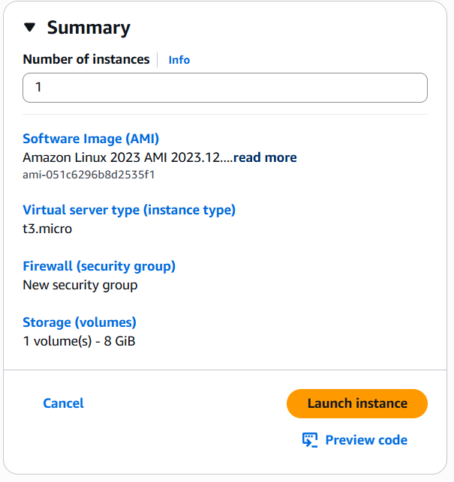

Launch instance successfully

The Success message confirms that the EC2 instance has been successfully initiated.
AWS provides the newly created Instance ID for identification and management.
The Next Steps section provides useful options such as connecting to the instance, creating billing alerts, and configuring additional AWS services.
At this stage, the instance is ready for further configuration and access.

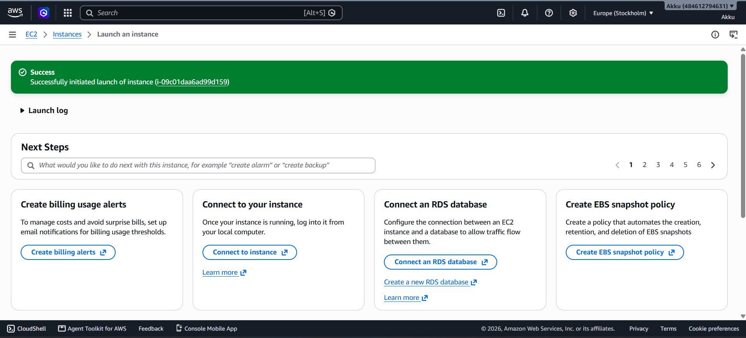

Initializing of instance

After launching, AWS begins the initialization process for the EC2 instance.
During this stage, AWS allocates the required compute, storage, and networking resources.
The selected AMI is loaded and the operating system starts booting.
Once initialization is complete, the instance changes to the Running state and becomes ready for use.

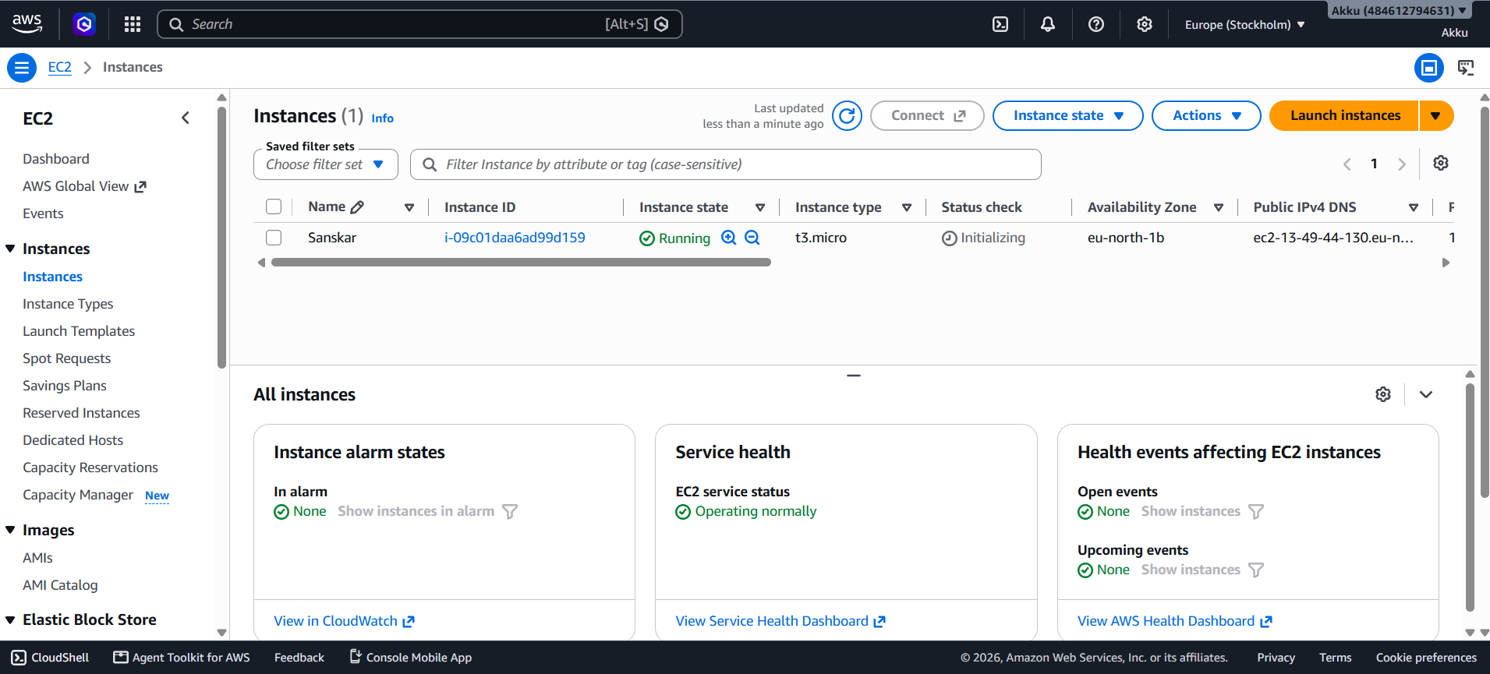

Connect Instance

Amazon EC2 (Elastic Compute Cloud) provides virtual servers in the AWS cloud. After launching an EC2 instance, it can be accessed remotely through a secure connection. The connection is established using methods such as EC2 Instance Connect or SSH. Proper authentication, a key pair, and security group rules are required to access the instance. Once connected, users can interact with the Linux operating system through the terminal and perform various tasks using Linux commands.

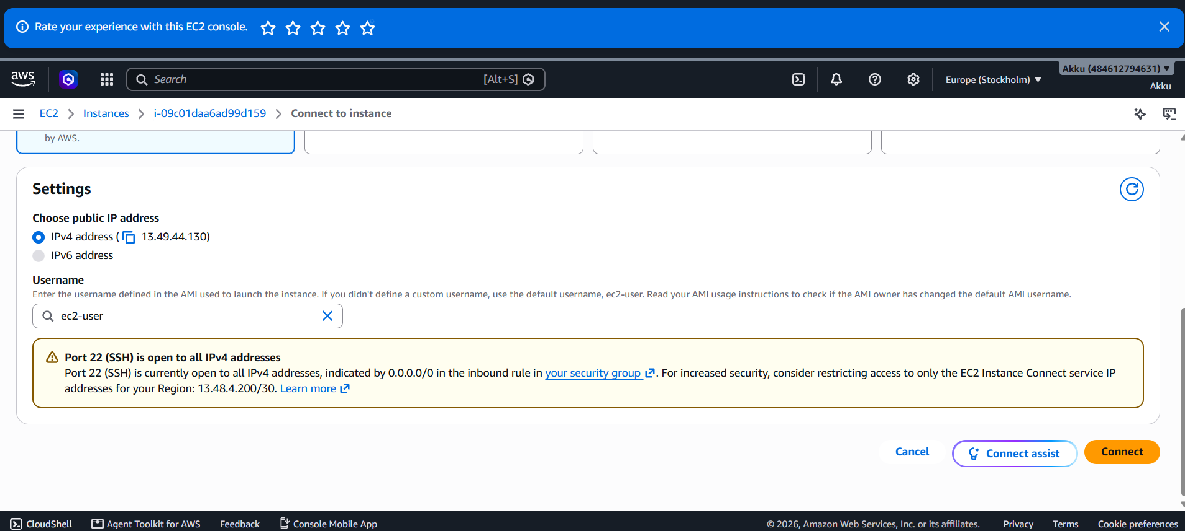

Leniux Command

Linux commands are used to interact with and manage the Linux operating system through the command line. They allow users to perform tasks such as creating directories and files, navigating between directories, viewing file contents, editing files, and deleting unwanted files. Linux commands are generally short, powerful, and case-sensitive.
Examples: pwd, ls, mkdir, cd, touch, nano, cat, rm.

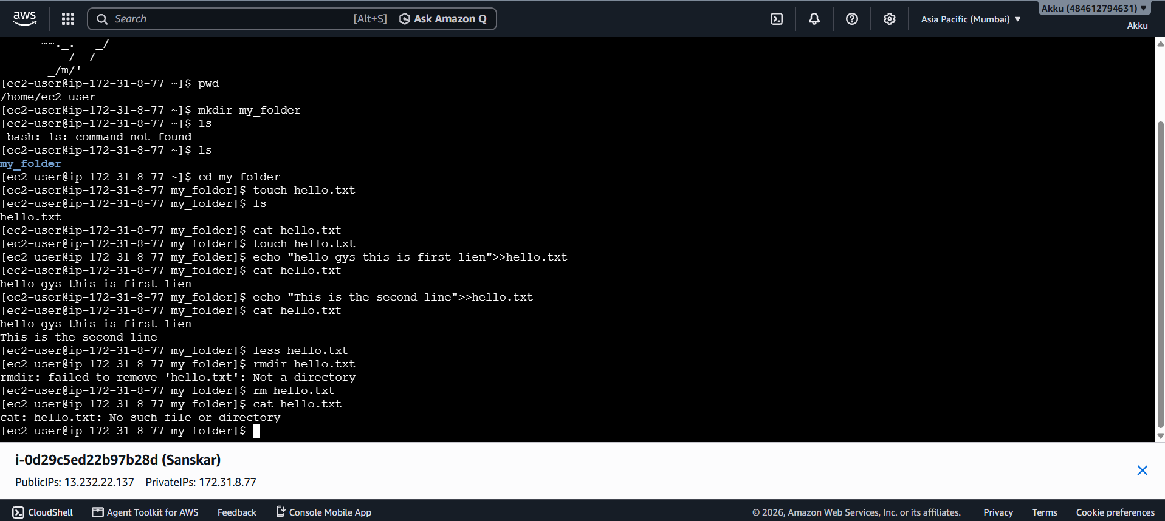

Deleted Instatnce Process

- To delete an EC2 instance, first select the required instance from the EC2 Instances page.
- Choose Instance state → Terminate instance.
- Confirm the termination when prompted.
- After termination, the instance status changes to Terminated.
- A terminated EC2 instance cannot be restarted or recovered.
- Before finishing, check EBS Volumes, Elastic IPs, and Snapshots to ensure no unnecessary billable resources are left.

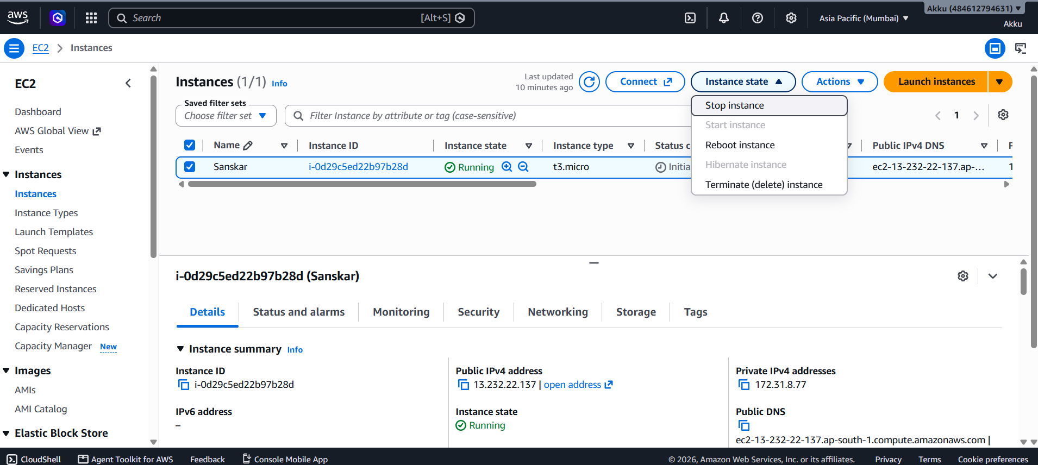

Instance Deleted Successfully

• A deleted/terminated EC2 instance is permanently removed from active use.
• Its instance status changes to “Terminated.”
• A terminated instance cannot be restarted or recovered.
• The instance no longer consumes EC2 compute resources.
• However, associated resources such as EBS volumes, Elastic IPs, or snapshots may still exist and can cause charges.
• Therefore, unnecessary associated resources should also be deleted to avoid extra costs.

